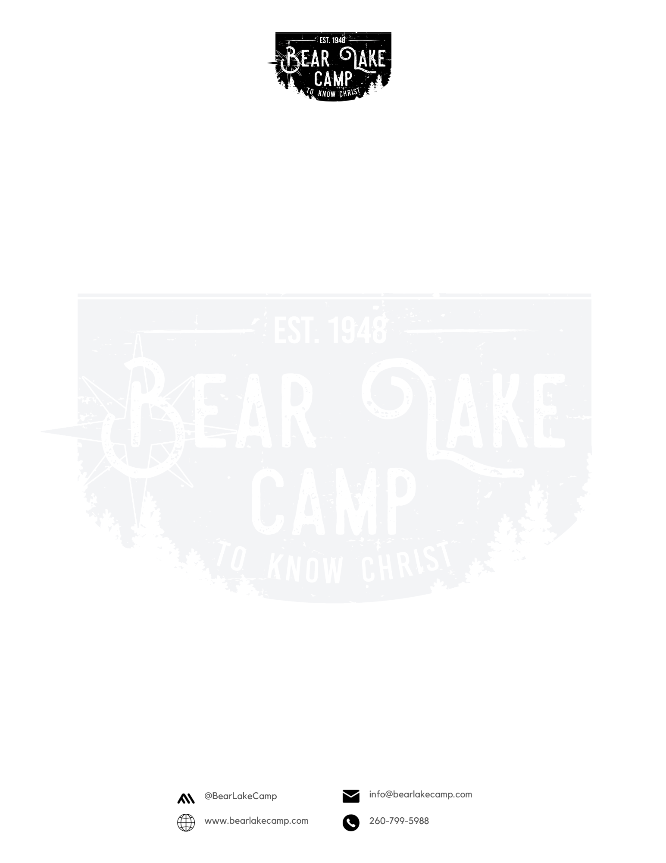

Summer 2026 – Worthy

Thank you for registering for Bear Lake Camp. We look forward to seeing you this summer!

When you arrive at camp:
- Go to the Dining Hall porch to check-in and complete the registration process:
  - Bring any registration money that is still due
  - Bring any store and/or offering money not already paid
  - Bring any medications packaged and clearly marked so they can be given to the camp nurse. (*see bottom of page)
- Once check-in and registration are complete you may find your cabin and move in for the week. Please do not go to the cabins before you check-in.

Check out will be at 6:30 pm on Thursday, July 23, 2026.

Here are some things to keep in mind as you prepare for camp:

What to bring:
- Bedding for a twin size bunk bed
- Bible, pen or pencil
- Soap, shampoo, toothbrush and toothpaste, other necessary toiletries
- Towels & washcloths
- Modest one-piece swimsuit and beach towel
- Comfortable, casual, modest clothing: T-shirts, shorts, jeans/sweats, hoodie/jacket
- Athletic shoes and socks will be needed for some activities
- Sandals or flip-flops
- Bag for dirty clothes

You may also want:
- Camera
- Sunscreen, Mosquito repellent
- Notebook
- Flashlight
- Raingear
- Fishing gear, swimming aides
* All prescription and non-prescription medication must be turned into the camp nurse at registration. Prescription meds must contain the prescription label. If your child is on a regular prescription med and you choose not to send it to camp, a doctor’s note is required to dismiss your child from that med for the week of camp. Non-prescription meds must be in their original package, contain the camper’s name, and dosage requirements.

Do Not Bring:
- Cell phones: By registering and attending a BLC session, you are agreeing to give up cell phones and other electronic devices (listed below) during the entire session.
- All electronics: i-pods, mp3 players, computers, DVD players, games, radios, TV’s, walkie-talkies, pagers, etc.
- Firearms, knives, weapons or fireworks of any kind
- Alcohol, tobacco, illegal drugs
- Food, snacks, candy, beverages**
- Money – other than what is deposited for Snack Shack

** If due to allergies, special foods and snacks are necessary, please contact us (email info@bearlakecamp.com) prior to camp and turn in food/snacks at registration.

Parents,
Here are some things you can do to help make your child’s camping experience better before he/she even arrives at camp.

- Please mark all personal items with the camper’s name.
- Let your child know that you will be providing money for him/her to use at the camp store and that he/she will have a card at the store where the camp staff will keep track of how much money they have spent and have left to spend. They don’t need to worry about keeping track of their money.
- Let your child know they will receive a tshirt included in the registration fee. When your camper goes to the store during the designated time, he/she simply tells the store staff which T-shirt he/she wants.
- Let your child know if he/she purchased a camp picture, it will be given to the camper at check-out along with any unused store money and medications.
- If you attended camp as a child talk to your child about the fun and exciting things you did and learned at camp.
- Encourage your child to be willing to participate in all activities and try new things if he/she has the opportunity.
- Downplay any talk of homesickness by encouraging your child to make new friends and enjoy all the things he/she will be able to do at camp.
- Prepare your child by helping him/her understand he/she will be living in a cabin with several other kids and the importance of using good social skills and respecting other people’s property and space.
- Even if your child has attended camp before, let him/her know that things and people may be different this year.
- Encourage him/her to be flexible and go with the flow.
- Begin praying now for God to work in your child’s life during his/her camp experience

- Visit our website at bearlakecamp.com for more information. Once you’ve opened our website click on Summer Program, from the menu on the top of the page. From there click on Parent Info listed in the menu. Please read all the parent information before sending your child to camp.
- If you have additional questions or concerns, please call us prior to camp at
260-799-5988 or e-mail us at info@bearlakecamp.com
________________________________

Directions to Bear Lake Camp

From Fort Wayne:
Take Highway 33 North through Churubusco to Wolf Lake (approx. 29 miles). In Wolf Lake turn left on State Road 109. Go approx. 1 mile to County Road 200 South, turn right.
Go till road T’s at lake, turn right on 475 W which turns into 175 S. Take this around the back of the camp to 16th Street – turn left onto 16th Street. Parking is along 16th Street.

From Ligonier:
Take 33 South to Wolf Lake (approx. 11 miles). Turn right on State Road 109. Go approx. 1 mile to County Road 200 South, turn right. Then follow italic directions above.

From Columbia City:
Take State Road 109 North. Go 11 miles to County Road 200 South, turn left. Then follow italic directions above.

